DoogyCat Service

I use Factory pattern to break 3 cases

Test case 1 Shiba

use design pattern for case 1 show only odd image

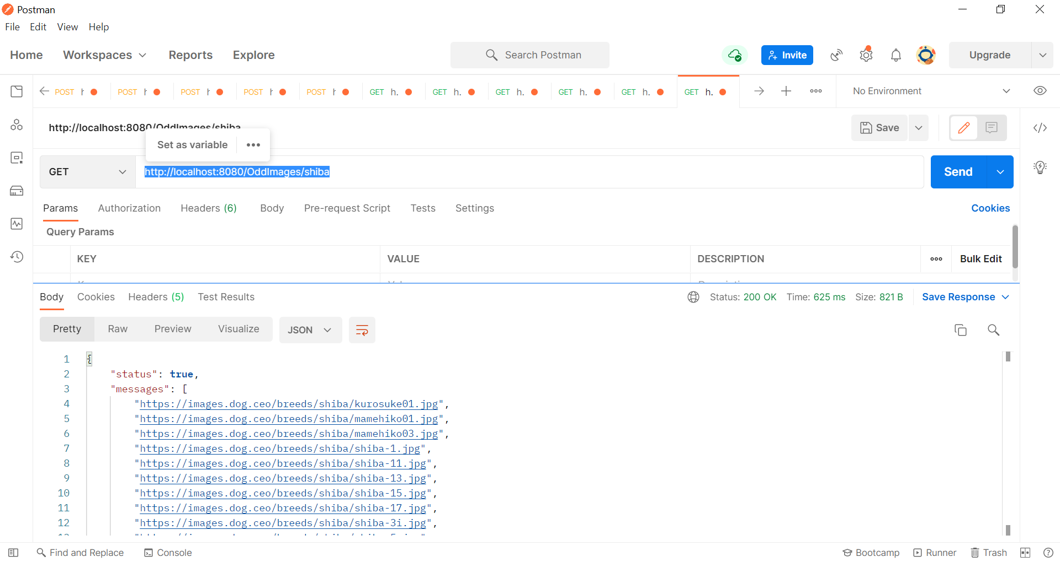

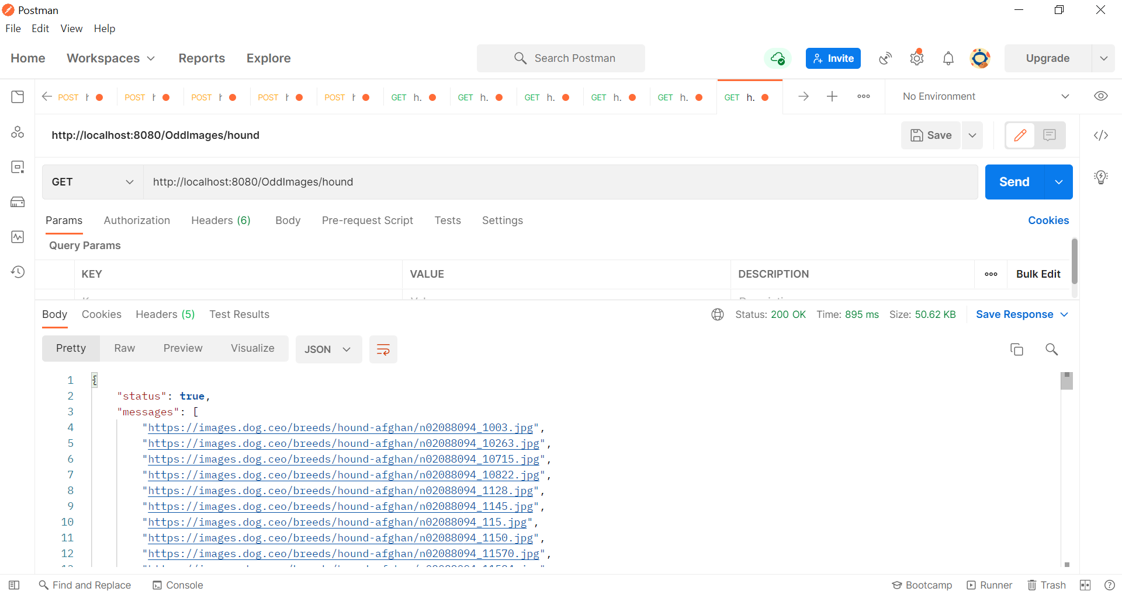

Test case 2 SheepDog

use design pattern for case 2 make child to parent

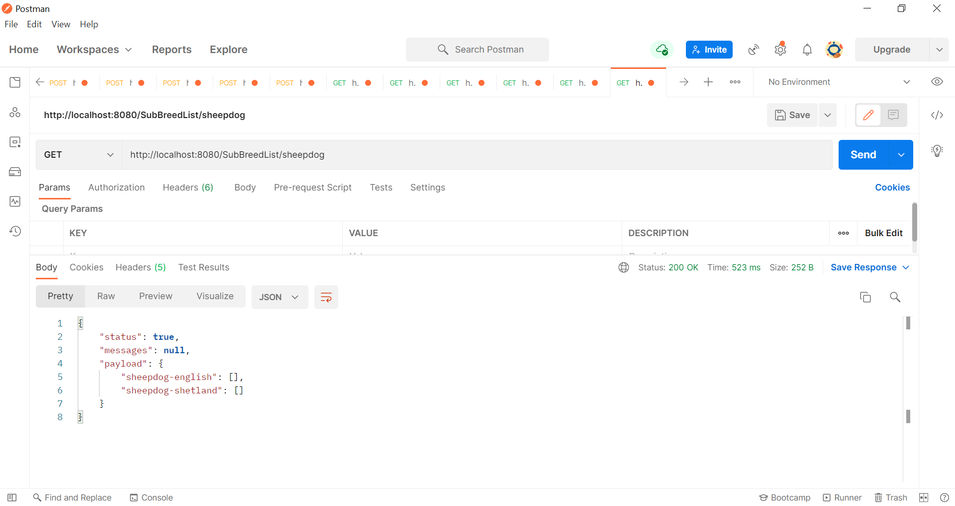

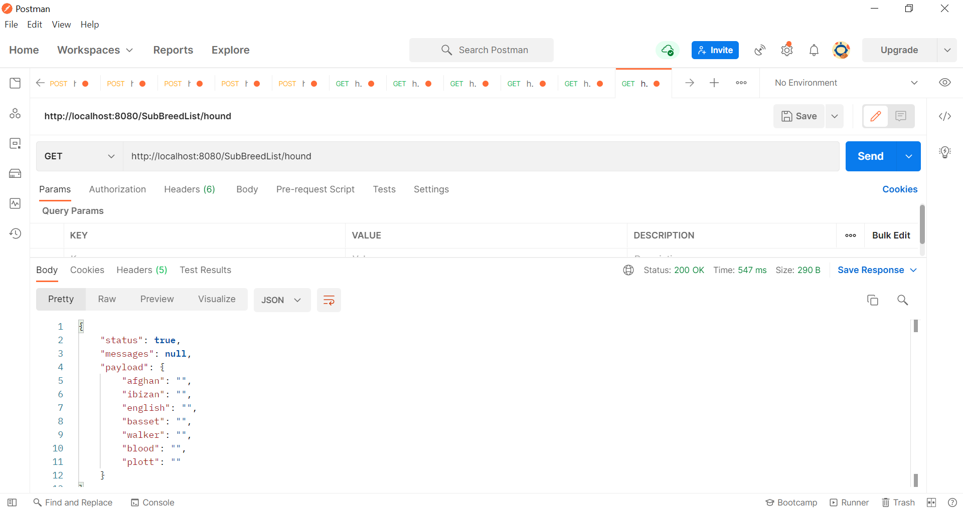

Test case 1 Terrier

use design pattern for case 3 make child to parent also images

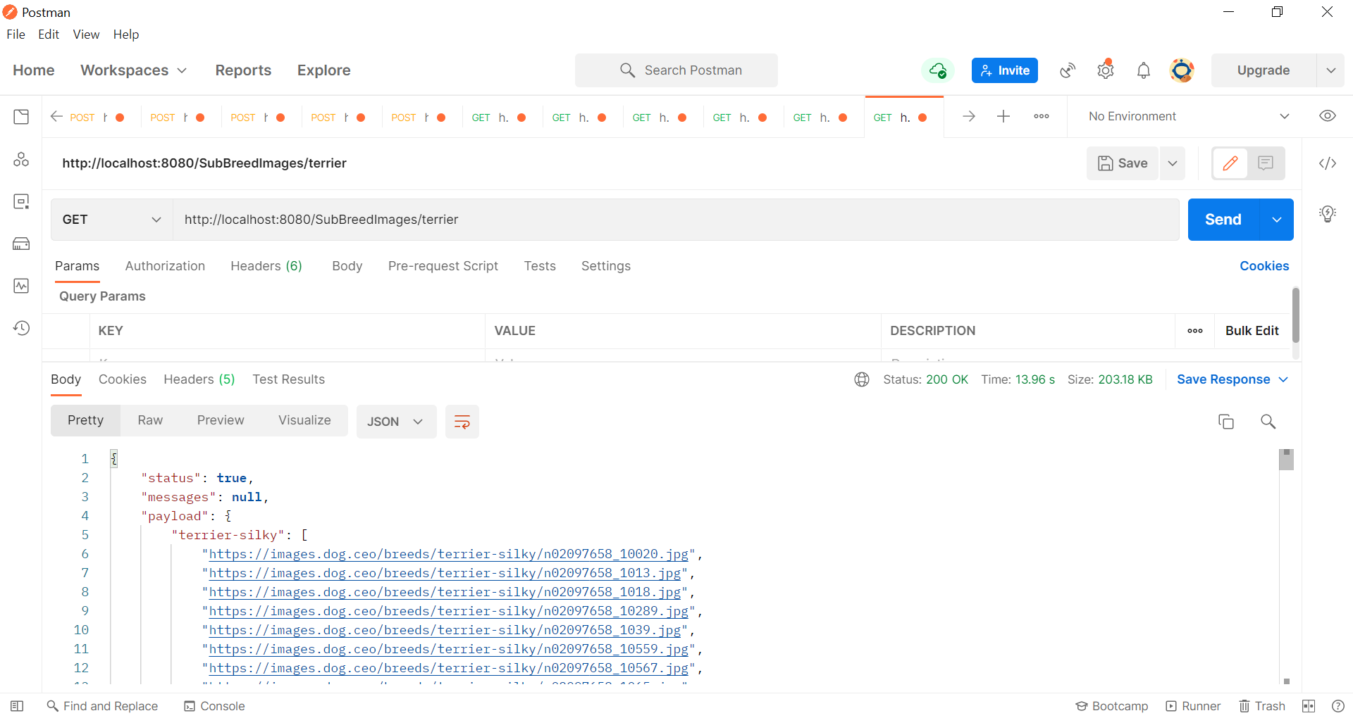

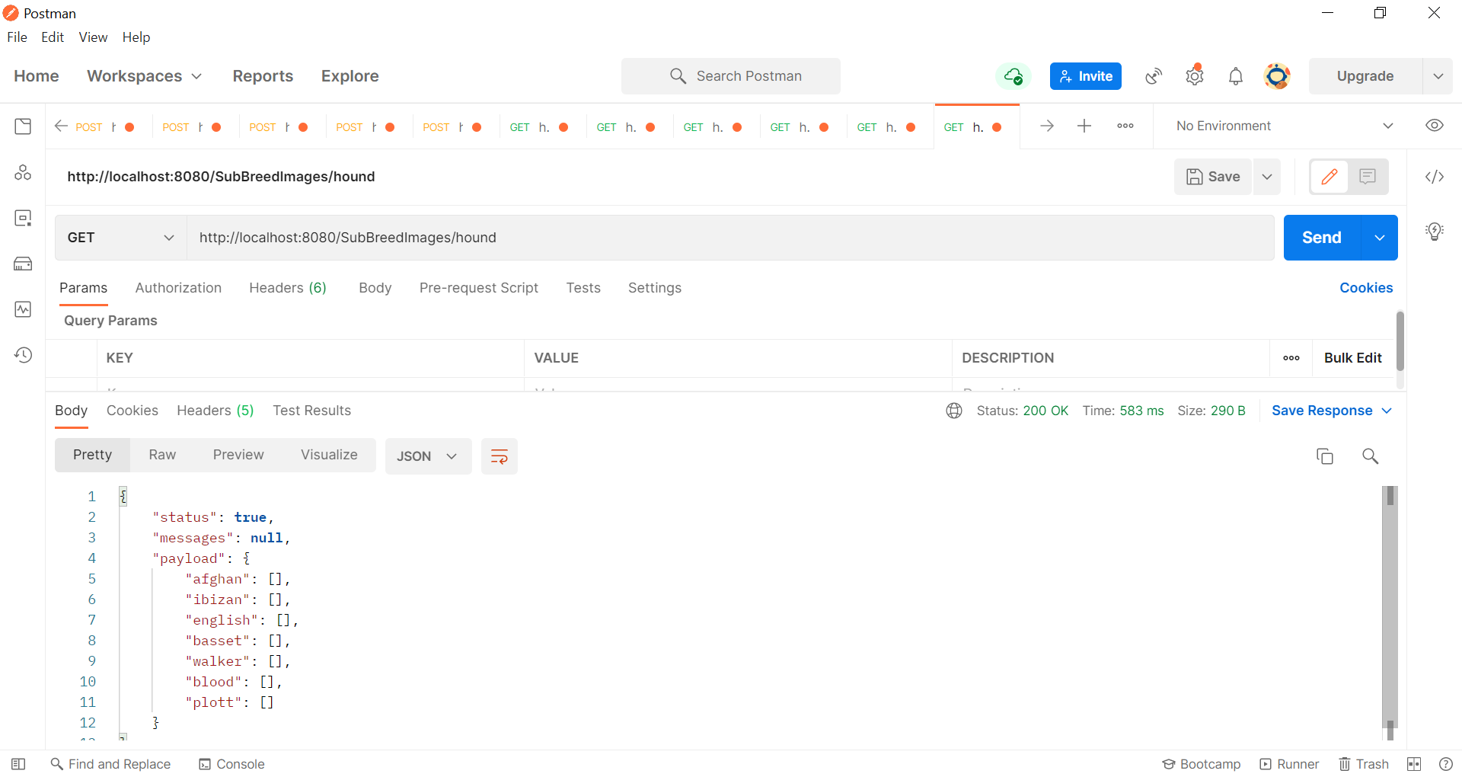

Note :

cek list http://localhost:8080/List

Save data to db [http://localhost:8080/S](http://localhost:8080/List)avetoDB

Delete All [http://localhost:8080/E](http://localhost:8080/List)mptyDB